Innovation Professional Program: AI Agent Build-out Plan
Draft for discussion, 11 September 2026

/ Executive summary
The TEC Innovation Professional Program needs two AI agents that act as always-available coaches at its two hardest gates: the move from a validated idea into a prototype, and the move from a built prototype into a Demo Day pitch. Both agents should be built on Claude as a single shared platform with one architecture, one bilingual design system and one evaluation discipline, then specialised through their knowledge, rubrics and tools.
The recommended build is a coach-and-gate model. Each agent runs a structured session with the participant, produces a scored, evidence-backed assessment against a fixed rubric, and hands a verdict to a human mentor or coach who confirms the gate decision. The agent never decides alone. Scores are computed deterministically in application code from model-generated rubric ratings, every claim is anchored to what the participant submitted or to a cited source, and every output follows a fixed JSON schema so the interface, the mentor view and the program dashboard always receive predictable data.
This document sets out the reference architecture, the end-to-end process flow of each agent, the screens and interaction patterns, the reliability controls and the build roadmap. It is written so that a product owner, a designer and an engineering team can start from it directly.
→ Recommendation: build the Idea Validation Agent first, pilot it on a subset of the cohort, then reuse 70 percent of the platform for the Pitch Validation Agent.

/ Where the agents sit in the program
The program runs through seven phases. The two agents are embedded at the two transitions where participants most often stall and where mentor time is scarcest.
Phase | What participants do | Agent involvement | Gate to next phase
1. Idea generation | Explore challenges, capture ideas on the idea canvas | None (optional idea-sharpening prompts) | Idea canvas complete
2. Idea validation | Interviews, desk research, first evidence | None (human mentor workshops) | Evidence attached to canvas
3. Idea Validation Agent with prototype suggestion | Structured validation session with the agent, receive scorecard and prototype plan | Agent 1: assess, challenge, score, recommend prototype | Mentor confirms verdict: Ready, Refine or Pivot
4. Prototype building | Build the digital or no-code prototype, run tests | Agent 1 in follow-up mode: test plan check-ins | Prototype and test results uploaded
5. Pitch readiness | Draft deck and script using the TEC pitch template | None (template, coach sessions) | Draft deck uploaded
6. Pitch Validation Agent | Deck review, mock jury, iteration | Agent 2: critique, mock Q&A, readiness score | Coach confirms Demo Day readiness
7. Demo Day | Pitch to jury | Agent 2 generates jury pack and participant brief | Jury decision

/ Design principles
- Coach, not judge. The agent explains, challenges and recommends. A human mentor or coach owns every gate decision. This keeps trust high with participants and keeps accountability with the program office.
- Fixed rubric, deterministic score. The model rates each dimension against written anchors; application code applies the weights and computes the score. The same submission produces the same verdict category.
- Every statement is anchored. Feedback references a canvas field, a slide number, a transcript line or a cited source. Market or competitor claims come only from tool results with a link, otherwise they are labelled as assumptions to verify.
- Structured in, structured out. Inputs are captured through forms and templates before free conversation starts. Outputs follow a JSON schema that drives the interface and the dashboard.
- Bilingual by design. English and Arabic are first-class. The agent answers in the language the participant writes in, the interface supports right-to-left layout, and the rubric anchors and evaluation sets exist in both languages.
- Observable and testable. Every session is logged, every prompt is versioned, and a golden set of ideas and pitches is re-run before any change goes live.

/ Reference architecture on Claude
Both agents share one platform. The differences sit in the knowledge packs, the rubrics, the tools and the screens. The architecture has five layers.
Layer | Components | Notes
Experience | Web application (participant, mentor, program office, jury views), EN/AR with RTL, streaming chat, structured cards, file upload | Responsive web first; TEC intranet or SSO integration in the pilot
Orchestration | Agent runtime built with the Claude Agent SDK or the Messages API with tool use; session state machine; structured output validation; retry and fallback logic | One orchestrator, two agent definitions; the state machine, not the model, controls which stage the session is in
Knowledge and skills | Agent Skills packaging the TEC strategic priorities, rubric anchors, pitch template, prototype catalogue, glossary EN/AR, worked examples | Skills load on demand so the system prompt stays small and cacheable
Tools | Idea record read/write, deck parser (PDF and PPTX to structured slides), web search with citations, prototype catalogue lookup, calendar and mentor assignment, export to PDF | Each tool has a strict schema; the model never writes to the record directly, it proposes and the application commits
Data and governance | Participant workspace, versioned idea record, assessment history, session logs, evaluation datasets, audit trail, role-based access | Hosting region and retention settings to be confirmed with TEC IT and legal before the pilot

Model usage pattern
- Interactive turns (clarifying questions, explanations, mock jury questions) use a fast model to keep latency under three seconds per turn.
- Assessment passes (rubric rating, prototype recommendation, deck critique, readiness score) use the most capable model available, run once per submission, and return a schema-validated JSON object.
- A second critique pass reviews the first assessment for unsupported claims, missing anchors and rubric drift before it is shown to the participant. This is the main quality control on the model side.
- Prompt caching is applied to the system prompt, the rubric and the loaded skills so repeated turns in a session are cheap and fast.
- Deck files are passed through the Files API once per version and referenced in subsequent turns rather than re-uploaded.

Session state machine
Figures 1 and 2 in the agent chapters show each flow with its owner, decisions and loops. Each agent session is a finite set of stages. The application decides when to move stages based on completeness checks, not on the model deciding it is done. This is the single most important reliability decision in the design: it keeps sessions from drifting, guarantees every stage produces its expected artefact, and makes the interface predictable.
IDEA VALIDATION: intake -> clarify -> assess -> critique -> verdict -> prototype_plan -> mentor_review -> closed
PITCH VALIDATION: upload -> parse_check -> structure -> content -> coherence -> mock_jury -> readiness -> coach_review -> closed

/ Agent 1: Idea Validation Agent with prototype suggestion

Purpose and boundaries
The agent takes a completed idea canvas plus any evidence the team collected in phase 2, runs a structured challenge session, scores the idea against the TEC validation rubric, returns a verdict category and recommends the cheapest digital or no-code prototype that would test the riskiest assumption. It does not approve ideas, does not estimate budgets, and does not compare teams against each other.

Inputs and outputs
Inputs | Outputs
Idea canvas: problem, affected users, current workaround, proposed solution, expected value to TEC, alignment tags, known risks | Validation scorecard: six dimension ratings with anchors and evidence, weighted score, confidence level
Evidence pack: interview notes, data points, screenshots, links (optional, any format) | Verdict category: Ready to prototype, Refine and resubmit, Pivot, with the three most important reasons
Team profile: size, skills, available hours per week | Prototype plan: riskiest assumption, primary and alternative prototype, tool, fidelity, build estimate, test plan with success threshold
Program context loaded from skills: TEC strategic priorities, cohort deadlines, prototype catalogue | Mentor brief: one-page summary with points to probe in the mentor session

Process flow chart
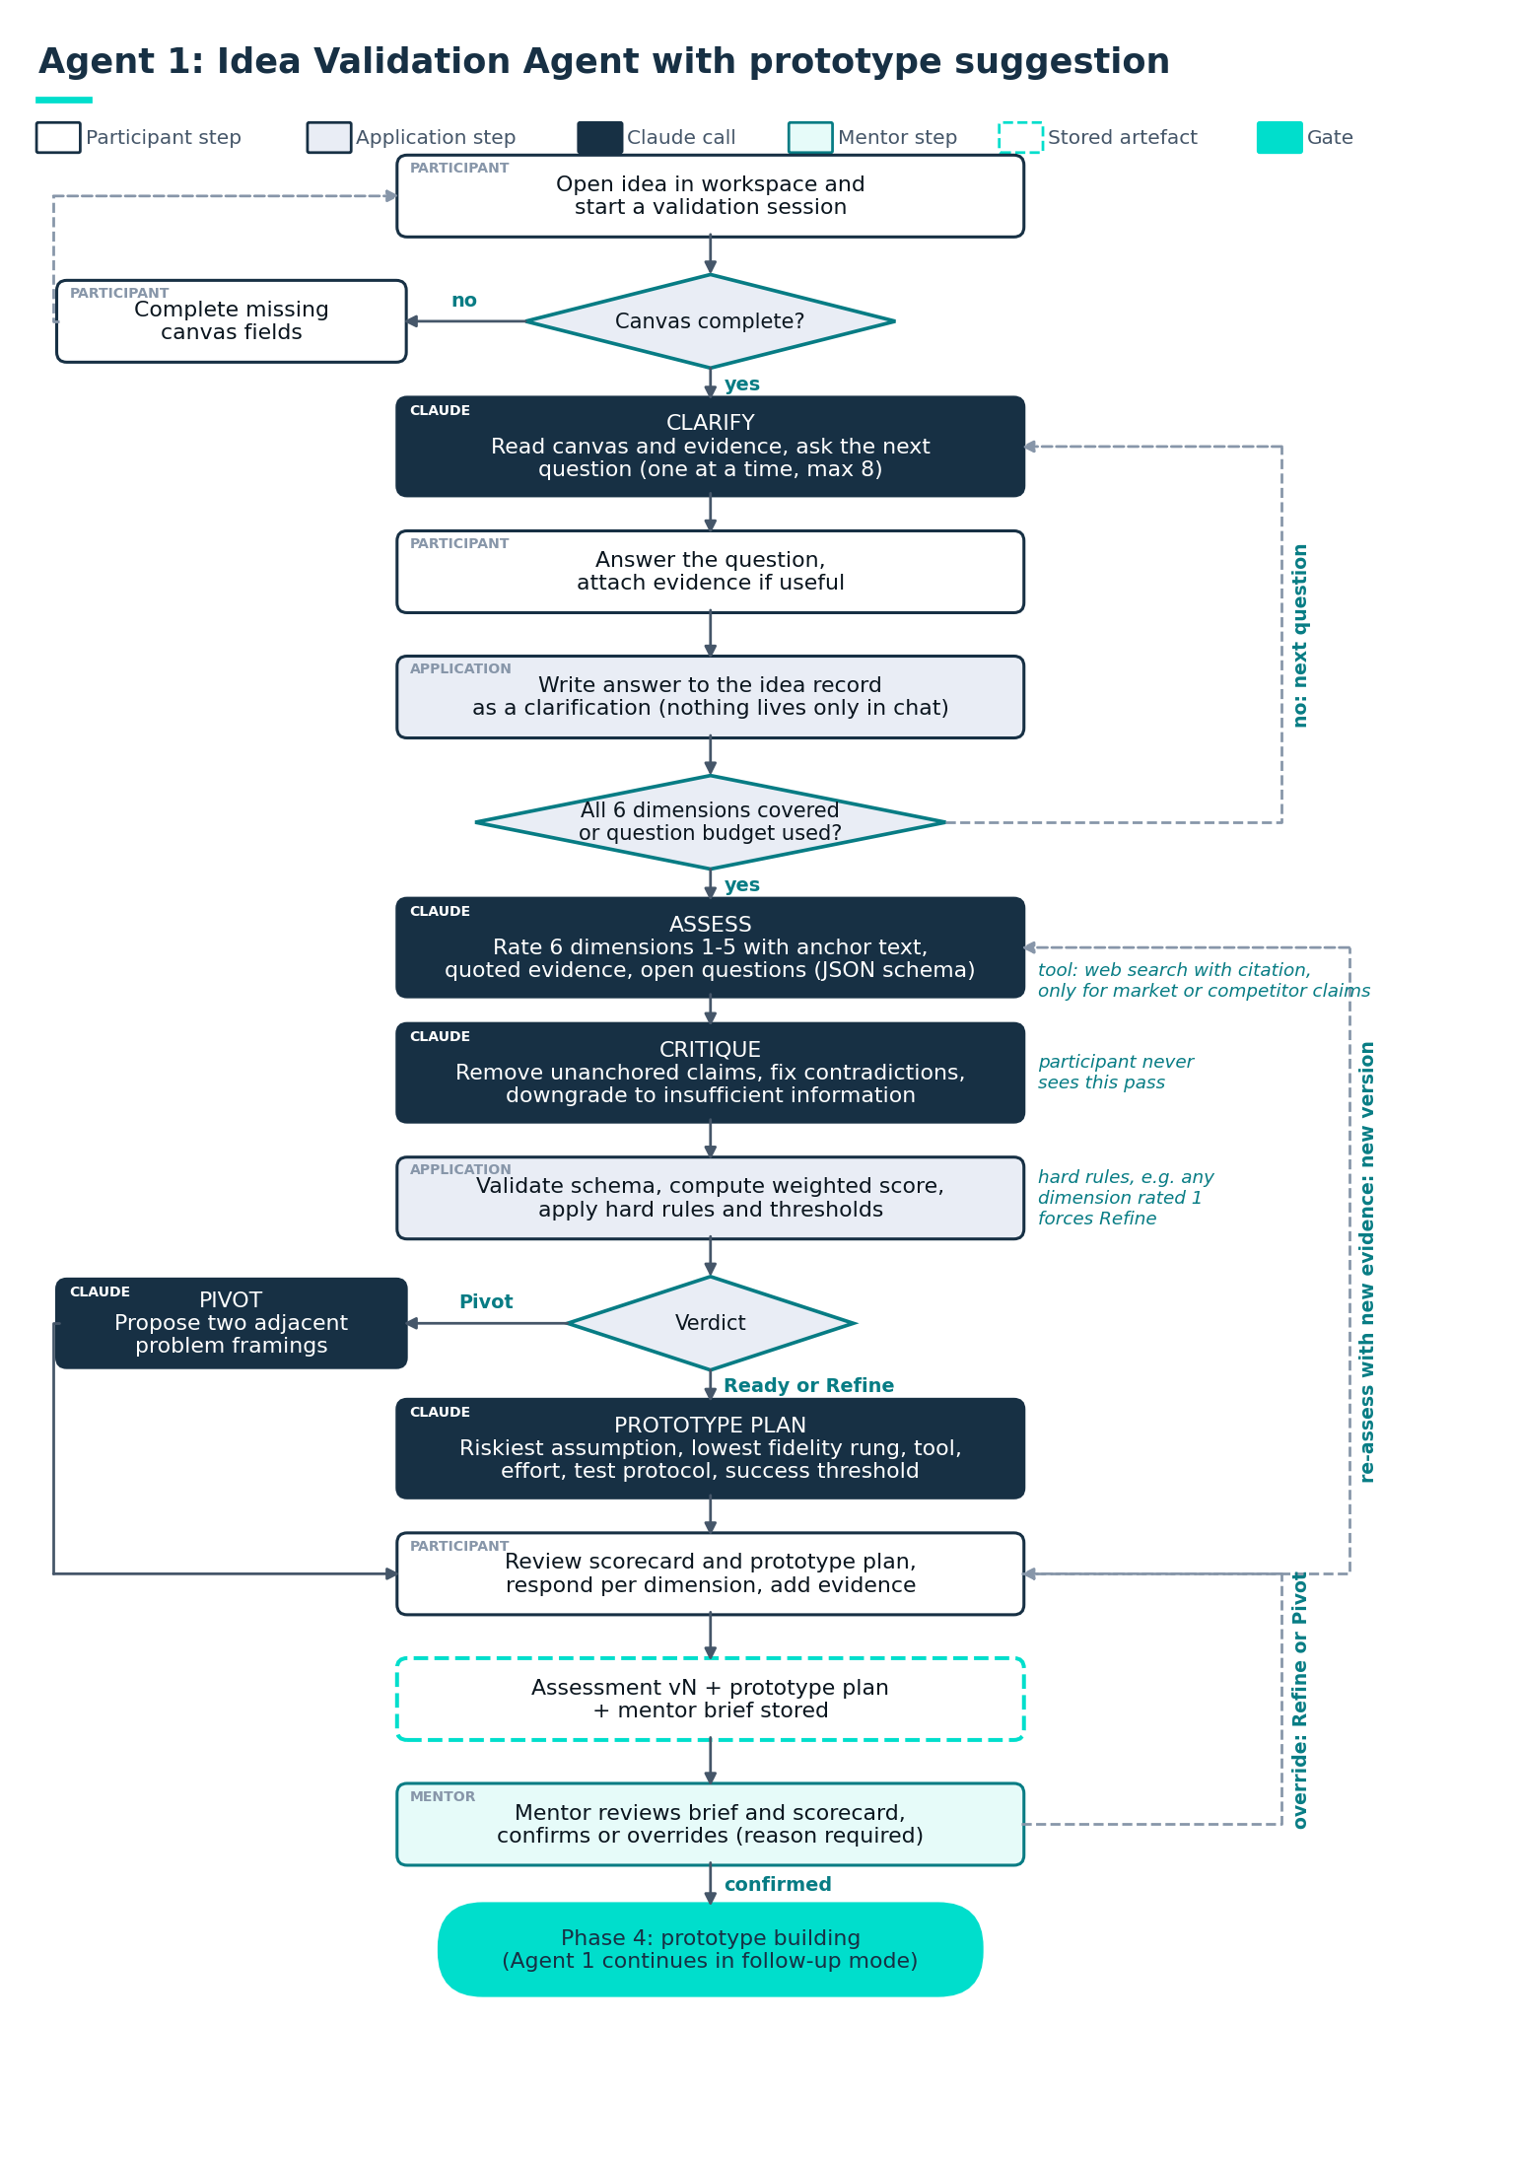
Figure 1. Idea Validation Agent: end-to-end flow with owners, decisions, loops and the mentor gate.

Process flow
- Intake. The participant opens the idea in the workspace and starts a validation session. The application checks canvas completeness; fields under a minimum length are flagged and must be completed before the session starts. No model call yet.
- Clarify. The agent reads the canvas and evidence, identifies the two or three weakest areas and asks up to eight adaptive questions, one at a time. Each question shows a short "why we ask this" line. Answers are written back to the idea record as clarifications, so nothing lives only in chat. The stage ends when the agent has coverage on all six dimensions or the question budget is used.
- Assess. One assessment call returns, per dimension, a rating from 1 to 5, the anchor text that justifies it, the specific evidence quoted from the record, and a list of open questions. Where the participant made a market or competitor claim, the agent may call web search and attach the source; unverifiable claims are labelled as assumptions.
- Critique. A second pass checks the assessment for ratings without evidence, evidence that does not exist in the record, contradictory ratings and tone. Flagged items are corrected or downgraded to "insufficient information". The participant never sees this pass.
- Verdict. Application code computes the weighted score, applies the verdict thresholds and hard rules (for example, a rating of 1 on Problem clarity forces Refine regardless of total), and renders the scorecard. The participant can respond to each dimension, add evidence and request a re-assessment; versions are kept side by side.
- Prototype plan. For Ready and Refine verdicts, the agent identifies the riskiest assumption and selects from the prototype catalogue the lowest-fidelity digital prototype that can test it, plus one alternative. It returns the tool, the screens or flows to build, an effort estimate in team-days, the test protocol, the number of test users and the success threshold.
- Mentor review. The assigned mentor receives the brief, sees the scorecard and the participant responses, and confirms, adjusts or overrides the verdict with a reason. The override reason is stored and feeds evaluation. Only a mentor action moves the idea to phase 4.
- Follow-up mode (phase 4). The agent reopens weekly in a lighter mode: checks progress against the test plan, helps interpret test results against the threshold, and flags when the riskiest assumption has changed.

Validation rubric
Weights reflect what matters at this gate: whether the problem is real and whether TEC should care. Feasibility is weighted lower because the prototype phase exists to answer it.
Dimension | Weight | Rating 1 anchor | Rating 5 anchor
Problem clarity | 20% | Problem stated as a solution or as a vague pain; no affected user named | Specific problem, named user group, frequency and cost of the problem evidenced
User evidence | 20% | No contact with affected users | Five or more user conversations or usage data confirming the problem and current workaround
Strategic fit with TEC | 20% | No link to a TEC priority or an area TEC explicitly does not pursue | Direct contribution to a named TEC priority with a plausible sponsor
Value and viability | 15% | Value not articulated or purely qualitative with no logic | Value mechanism explained (time, cost, revenue, risk, experience) with an order-of-magnitude estimate and assumptions listed
Feasibility | 15% | Depends on data, systems or approvals that are unavailable within the program | Can be prototyped with no-code tools and existing data within the phase 4 window
Novelty and risk awareness | 10% | Existing TEC or market solution ignored; no risks identified | Differentiation from existing solutions stated; top three risks named with mitigation

Weighted score | Verdict | Hard rules
3.6 to 5.0 | Ready to prototype | No dimension rated 1; User evidence at least 3
2.6 to 3.5 | Refine and resubmit | Any dimension rated 1 forces Refine even above 3.6
1.0 to 2.5 | Pivot | Strategic fit rated 1 forces Pivot; the agent proposes two adjacent problem framings

Prototype suggestion logic
The agent works down a fidelity ladder and stops at the first rung that can test the riskiest assumption. It never recommends building the full solution.
Rung | Prototype type | Typical tools | Tests | Effort
1 | Storyboard or one-page concept with a fake sign-up | Slides, Canva, a simple form | Interest and desirability | 1 to 2 team-days
2 | Clickable mockup of the core flow | Figma, Balsamiq | Usability and comprehension of the flow | 3 to 5 team-days
3 | No-code working prototype with real or sample data | Power Apps, Glide, Softr, Airtable, Power Automate | Value delivered in a real task | 5 to 10 team-days
4 | AI-assisted demo (for ideas that rely on language or documents) | Claude project or app built on the API, connected to sample documents | Whether the AI output is good enough for the user | 3 to 8 team-days
5 | Concierge or manual pilot behind a simple front end | Forms, spreadsheets, a human doing the work | Operational viability before automation | 5 to 10 team-days

Each plan states the assumption under test, the metric, the number of users, the success threshold and what the team does if the threshold is missed. The catalogue is a skill file the program office can extend without touching prompts.

UX and UI
The participant experience is a workspace, not a chat window. Conversation is one panel inside a structured page, and everything the agent produces becomes a persistent, editable object.
Screen | Layout and key elements | Interaction notes
Idea Workspace | Left: idea canvas as editable fields with completeness indicators. Right: agent panel. Top: phase stepper showing where the idea is in the program. | Start session button is disabled until the canvas passes completeness. Canvas edits during a session are highlighted as new evidence.
Validation Session | Agent panel in interview mode: one question at a time, "why we ask this" expander, progress bar over the six dimensions, skip and come back later option. | Streaming responses. Answers auto-save to the record. Participants can attach a file to any answer. Maximum eight questions, stated up front.
Scorecard | Six dimension cards with rating, anchor, quoted evidence, open questions. Radar view of ratings. Verdict banner with three reasons. Assumptions to verify listed separately from verified facts. | Each card has Respond and Add evidence actions. Re-assess creates a new version; a version switcher compares two side by side.
Prototype Plan | Primary and alternative plan as cards: assumption, prototype type, tool, screens to build, effort, test protocol, success threshold. Fidelity ladder graphic shows which rung was chosen and why. | Accept plan creates the phase 4 task list. Ask for a different approach reruns only this stage.
Mentor Review | One-page brief, scorecard, participant responses, override control with mandatory reason, points to probe list. | Mentor decision is the only action that moves the phase. Time to decide is tracked for the program office.

Tone and language behaviour
- Direct, specific, encouraging. Every critical point is paired with what a stronger answer would contain.
- The agent replies in the language of the participant message and keeps the same language for the whole session unless asked to switch. Scorecards can be toggled between English and Arabic.
- Glossary terms (for example rubric dimension names and verdict categories) are fixed in both languages so they read identically across the interface, the agent and the mentor brief.

/ Agent 2: Pitch Validation Agent

Purpose and boundaries
The agent takes the draft deck, an optional script or rehearsal transcript, and the validated idea record from phase 3, and prepares the team for Demo Day. It critiques structure and content slide by slide, checks that the pitch is consistent with what was validated and built, runs a mock jury, and produces a readiness score. The human coach confirms Demo Day readiness. The agent does not rank teams and does not predict jury outcomes.

Inputs and outputs
Inputs | Outputs
Pitch deck as PDF or PPTX, parsed into slides with text, notes and image descriptions | Structure check against the TEC pitch template with missing and misplaced elements
Script or rehearsal transcript (text; audio is transcribed by a speech-to-text service outside the agent) | Slide-by-slide critique, each comment anchored to a slide number and a quoted element
Idea record from Agent 1: verdict, scorecard, prototype plan and test results | Coherence report: claims in the deck versus evidence in the record, with drift flags
Demo Day format: time limit, jury composition, question time | Mock jury session log with model answers and improvement notes
Pitch rubric and jury personas loaded from skills | Readiness score, verdict (Ready, Rehearse, Rework), jury pack and participant brief

Process flow chart
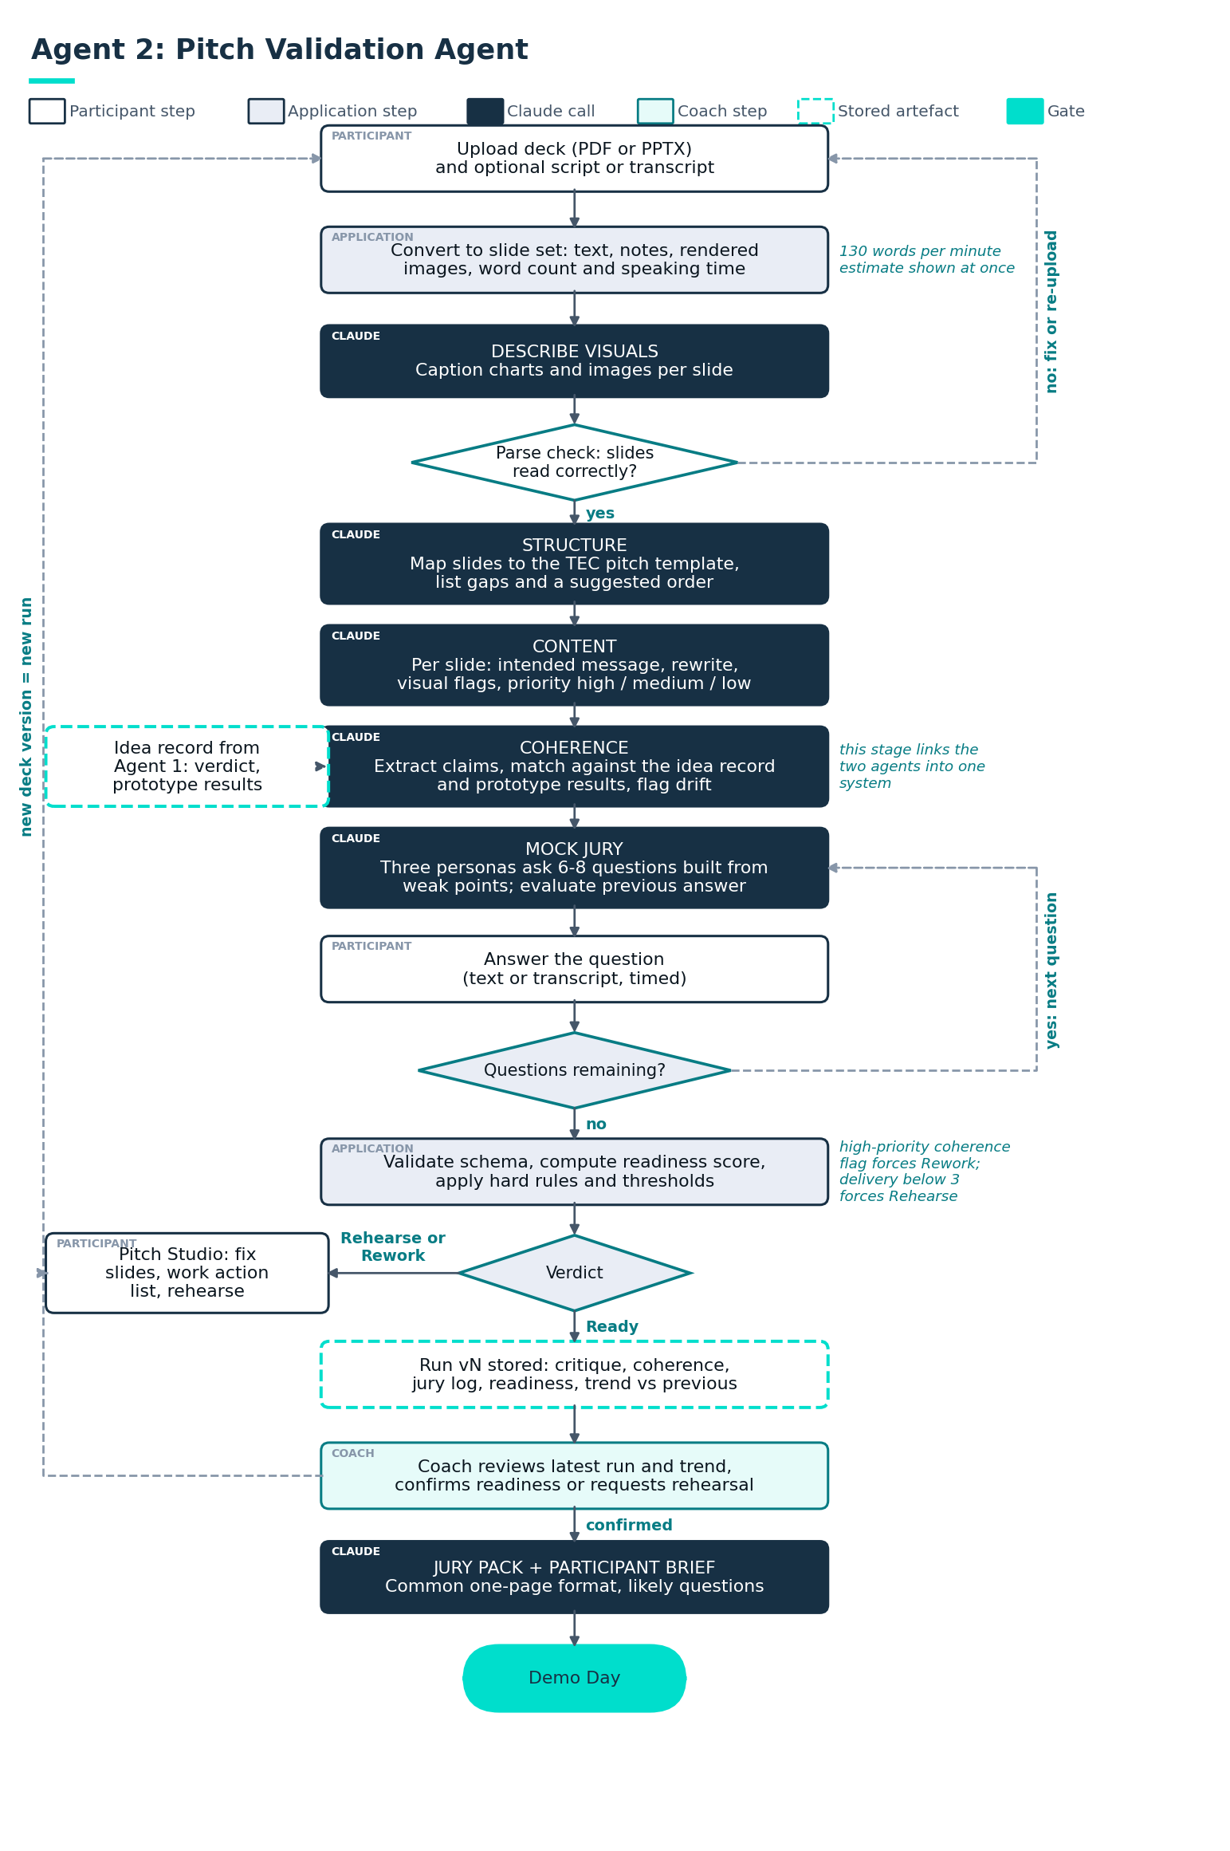
Figure 2. Pitch Validation Agent: end-to-end flow with the coherence link to the Agent 1 record and the coach gate.

Process flow
- Upload. The team uploads the deck and optionally a script. The application converts the file to a structured slide set: slide number, title, body text, speaker notes, image descriptions produced by the model from the rendered slide image.
- Parse check. The participant sees the parsed slides next to thumbnails and confirms nothing was lost. This prevents the agent from critiquing a deck it read incorrectly. Word count per slide and estimated speaking time (130 words per minute) are shown immediately.
- Structure. The agent maps slides to the TEC pitch template (problem, who is affected, what was validated, the prototype and what it proved, value to TEC, what is needed next, team). Missing elements, duplicated elements and ordering issues are listed with a suggested slide order.
- Content. For each slide the agent returns: the single message the slide should carry, whether the current slide carries it, concrete rewrite suggestions for headline and body, visual clarity flags (word count above 40, more than one chart, unreadable tables) and a priority of high, medium or low.
- Coherence. The agent extracts every factual claim in the deck and matches it against the idea record and prototype test results. Claims that are stronger than the evidence, numbers that changed without explanation, or a solution that drifted from the validated problem are flagged. This stage is what makes the two agents a system rather than two tools.
- Mock jury. The agent plays a panel of three personas (for example a business sponsor, an operations lead and a technology lead) and asks six to eight questions in turn. The participant answers in text or by pasting a transcript. Each answer receives a short evaluation and a model answer. Questions are drawn from the weak points found in earlier stages, so the mock jury is specific to this pitch.
- Readiness. Application code computes the readiness score from the rubric ratings and applies the thresholds. The team receives a prioritised action list of at most ten items. Re-uploading a new version creates a new run and shows what improved.
- Coach review. The coach sees the latest run, the trend across versions and the mock jury log, then confirms readiness or requests another rehearsal. On confirmation the agent generates the jury pack (one-page summary per team in a common format) and a participant brief with the likely questions.

Pitch rubric
Dimension | Weight | What the agent looks for | Source
Narrative clarity | 20% | One problem, one solution, one ask; a listener can restate the pitch in two sentences | Deck text, script
Evidence and traction | 20% | Prototype results, user quotes and data presented honestly and matching the record | Deck, idea record, coherence report
Value to TEC | 20% | Value mechanism and order of magnitude stated, linked to a named priority | Deck, idea record
Plan and ask | 15% | Clear next step, resources requested, owner and timeline | Deck
Delivery and timing | 10% | Within time limit, speaking pace, no slide overrun | Script or transcript word count and structure
Visual clarity | 5% | One message per slide, readable text, charts that support the point | Slide heuristics and image descriptions
Q&A resilience | 10% | Answers are direct, honest about limits, backed by evidence | Mock jury log

Readiness score | Verdict | Hard rules
3.8 to 5.0 | Ready for Demo Day | No unresolved high-priority coherence flag
2.8 to 3.7 | Rehearse | Delivery below 3 forces Rehearse
1.0 to 2.7 | Rework | Any high-priority coherence flag forces Rework until resolved

UX and UI
Screen | Layout and key elements | Interaction notes
Pitch Studio | Left: slide thumbnails with colour-coded priority dots. Centre: selected slide at readable size with parsed text. Right: agent comments for that slide, rewrite suggestions with Copy action. | Clicking a comment highlights the referenced element. Filters for high priority only and unresolved only. Version selector at the top.
Structure Map | Template sections as columns, slides as cards placed under the section the agent mapped them to, gaps shown as empty columns. | Drag a card to correct the mapping; the agent re-runs structure and content for affected slides only.
Coherence Report | Two-column list: claim in the deck (with slide number) versus evidence in the record (with link). Status per row: supported, overstated, changed, unsupported. | Each row has Fix in deck and Update record actions so the team resolves drift in the right place.
Mock Jury | Full-screen rehearsal mode: persona card, question, countdown timer for the answer, text or transcript input. After the session: log with evaluation and model answers. | Timer defaults to the Demo Day question format. A Practise again button reshuffles questions from the same weak points.
Readiness Dashboard | Score gauge, seven dimension bars, version trend, prioritised action list with checkboxes, coach status. | Actions link back to the slide or the mock jury item. Export participant brief as PDF.
Coach Review | Latest run, trend, mock jury log, confirm or request rehearsal control with reason, jury pack generation. | Coach confirmation triggers jury pack generation for the program office.

/ Reliability controls
Reliability comes from the surrounding system as much as from the model. The controls below apply to both agents and are the acceptance criteria for going live with a cohort.
Risk | Control | Where it lives
Session drifts or loops | Application-owned state machine; the model only works inside the current stage; hard budgets on questions and turns | Orchestration
Inconsistent scoring | Written anchors per rating; ratings returned in a JSON schema; weights and thresholds applied in code; calibration set of 30 ideas and 20 pitches rated by mentors, agreement measured before launch and after each prompt change | Skills, orchestration, evaluation
Fabricated facts or sources | Claims about markets, competitors or TEC systems only from tool results with a link; otherwise labelled assumption; critique pass removes unanchored statements; no free-text numbers in scorecards | Prompts, tools, critique pass
Misread deck | Parse check screen where the participant confirms slide text; image descriptions generated from rendered slides; per-slide confidence shown | Agent 2 flow
Feedback the participant cannot act on | Every comment carries a slide or field anchor, a priority and a concrete rewrite or next step; output schema rejects comments without an anchor | Output schema
Cross-team leakage | Sessions are scoped to one idea record; no retrieval across teams; skills contain program knowledge only, never other teams' content | Data layer, access control
Language quality gaps in Arabic | Bilingual glossary fixed in skills; evaluation set includes Arabic submissions; Arabic reviewer signs off tone and terminology before launch | Skills, evaluation
Over-reliance on the agent | Mentor and coach gates are mandatory; override reasons are captured and reviewed weekly by the program office | Process
Model or API unavailability | Retries with backoff; fallback to the fast model for interactive turns; assessments queued and the participant notified; sessions resume from the last completed stage | Orchestration
Prompt regressions | Prompts, skills and schemas versioned; the golden set is re-run in CI; a release is blocked if agreement with mentor ratings drops below the threshold | Evaluation, release process

Evaluation programme
- Golden set: 30 idea canvases and 20 pitch decks from past programs or synthetic cases, each with mentor ratings and expected verdicts in English and Arabic.
- Metrics: exact verdict agreement, mean absolute rating difference per dimension, share of comments with valid anchors, share of unsupported claims caught by the critique pass, participant usefulness rating, mentor override rate and reasons.
- Cadence: full run before launch, before each release, and a sampled review of 10 percent of live sessions weekly during the cohort.

Data, confidentiality and access
- Roles: participant (own team only), mentor and coach (assigned teams), program office (all teams, aggregate analytics), jury (jury packs only, after coach confirmation).
- Data classification and retention rules for idea content, session logs and uploaded decks to be agreed with TEC information security before the pilot, including hosting region and whether session data may be used to improve prompts.
- No personal data beyond name, role and team is needed by either agent. Uploaded evidence is checked for personal data of interview participants and masked before storage.
→ These points need confirmation with TEC IT and legal; they are design assumptions, not statements of TEC policy.

/ Bilingual English and Arabic design
- Language detection per message, with the session language pinned after the first participant message and a visible switch.
- Right-to-left layout for Arabic across the workspace, including mirrored steppers, tables and the slide critique panel; numerals and slide numbers stay consistent in both directions.
- Fixed bilingual glossary for rubric dimensions, verdict categories, prototype types and template sections, stored as a skill and used by the interface and the agent alike.
- Arabic typography tested at body and caption sizes; line height increased for Arabic script; mixed-direction strings (English tool names in Arabic sentences) handled with explicit direction marks.
- Evaluation set and golden set include Arabic submissions and Arabic-language decks; an Arabic-speaking mentor reviews tone before launch.

/ Build plan
Stage | Duration | Scope | Exit criteria
0. Foundations and calibration | 2 weeks | Confirm rubrics and thresholds with the program office; collect the golden set; write skills (priorities, glossary, prototype catalogue, pitch template); agree data and access rules with TEC IT | Rubrics signed off; golden set rated by mentors; architecture approved
1. Agent 1 MVP | 4 weeks | Orchestrator and state machine; idea record; intake, clarify, assess, critique, verdict stages; scorecard and mentor review screens; EN/AR | Verdict agreement with mentors above 80 percent on the golden set; end-to-end session under 15 minutes
2. Prototype plan and pilot | 2 weeks | Prototype suggestion stage and screen; follow-up mode; pilot with 5 to 8 teams; weekly session review | Pilot teams rate usefulness 4 of 5 or above; override rate and reasons reviewed
3. Agent 2 build | 4 weeks | Deck parser and parse check; structure, content, coherence stages; Pitch Studio and Coherence Report; mock jury; readiness; coach review | Anchored comment rate above 95 percent; readiness agreement with coaches above 80 percent
4. Hardening and Demo Day | 2 weeks | Load testing for cohort peaks; fallbacks; jury pack and participant brief; program office dashboard; runbook | Full cohort run completed; no open high-severity issues

Total elapsed time is around 14 weeks, sequenced so Agent 1 is live before the cohort reaches phase 3 and Agent 2 is live before phase 6. Stages 2 and 3 can overlap once the platform is stable.

Team
- Product owner from the program office; one designer with Arabic UX experience; two engineers (one on the agent runtime and evaluation, one on the web application); one prompt and skills author working with two mentors as domain calibrators; a TEC IT counterpart for hosting, identity and security.

Success metrics for the program office
- Time from idea canvas completion to mentor-confirmed verdict, targeted at under five days versus the current mentor-only cycle.
- Share of ideas reaching phase 4 with an agreed prototype plan and test threshold.
- Improvement in readiness score between the first and last pitch version per team.
- Mentor and coach hours per team, and participant usefulness ratings per session.

/ Appendix A: Output schemas
Schemas are enforced with structured outputs and validated again in the application before anything is rendered or stored. Abbreviated for readability.

Idea validation assessment
{
"idea_id": "string", "version": "integer", "language": "en | ar",
"dimensions": [ {
"name": "problem_clarity | user_evidence | strategic_fit | value_viability | feasibility | novelty_risk",
"rating": 1-5 | null, // null = insufficient information
"anchor": "string", // the written anchor that justifies the rating
"evidence": [ { "source": "canvas.field | clarification.n | evidence.file | web", "quote": "string", "url": "string?" } ],
"open_questions": [ "string" ]
} ],
"assumptions_to_verify": [ "string" ],
"top_reasons": [ "string", "string", "string" ],
"confidence": "high | medium | low"
}
// verdict and weighted_score are computed by the application, not returned by the model

Prototype plan
{
"riskiest_assumption": "string",
"primary": { "rung": 1-5, "type": "string", "tools": ["string"], "build_items": ["string"],
"effort_team_days": { "min": n, "max": n },
"test": { "protocol": "string", "users": n, "metric": "string", "success_threshold": "string", "if_missed": "string" } },
"alternative": { ...same shape... },
"why_not_higher_fidelity": "string"
}

Pitch critique and readiness
{
"deck_version": "integer", "language": "en | ar",
"structure": { "mapping": [ { "slide": n, "section": "problem | users | validation | prototype | value | ask | team | other" } ],
"missing": ["string"], "suggested_order": [n] },
"comments": [ { "slide": n, "element": "title | body | visual | notes", "quote": "string",
"issue": "string", "rewrite": "string", "priority": "high | medium | low" } ],
"coherence": [ { "slide": n, "claim": "string", "record_ref": "string", "status": "supported | overstated | changed | unsupported" } ],
"dimensions": [ { "name": "string", "rating": 1-5, "anchor": "string", "evidence": ["string"] } ],
"actions": [ { "priority": 1-10, "text": "string", "link": "slide:n | jury:n" } ]
}

/ Appendix B: Prompt structure per agent
- Role and boundaries: coach for TEC program participants, what the agent does and does not do, language behaviour.
- Stage instruction: injected by the orchestrator for the current stage only, with its expected output schema.
- Skills: TEC priorities, rubric anchors, glossary, prototype catalogue or pitch template, loaded on demand.
- Evidence rules: what counts as evidence, how to label assumptions, when to call web search, how to cite.
- Worked examples: two calibrated examples per stage, one in English and one in Arabic, drawn from the golden set.
- Session context: the idea record, prior clarifications, previous version of the assessment when re-assessing.

/ Appendix C: Sample clarifying questions (Agent 1)
- Who exactly experiences this problem, how often, and what do they do about it today?
- What did the people you spoke to say in their own words? Please paste one or two quotes.
- Which TEC priority or team would sponsor this, and why would they care this year?
- If this worked perfectly, what would change in numbers: minutes saved, errors avoided, revenue, satisfaction?
- What data, system access or approval does a first prototype need, and do you already have it?
- What already exists inside TEC or in the market that solves part of this, and what is different about your approach?
- What is the one assumption that, if wrong, makes this idea not worth doing?

